Professional Development: Engineering Design Process and Teamwork

Speaker: Meri Johnson, CEEMS science coach, and Thomas Smith, CEEMS participant and physics teacher at Batavia High School
Date: Tuesday, June 15th, 2017
Time: 2:45-4:15 PM
Venue: University of Cincinnati, Swift Hall, Room 516

Prepared by:
Michael Sullivan, Princeton High School, Cincinnati, Ohio
RET Participant for Project #2: “Li-S batteries”

Figure 1: RET Program Coordinator Debbie Liberi(c) introduces Thomas Smith (l) and Meri Johnson (r).

This session was delivered in room 516 of Swift Hall at the University of Cincinnati by Thomas Smith (a high school physics, chemistry, and physical science teacher who is in the 5th cohort of the CEEMS program) and Meri Johnson (a CEEMS science coach and National Board Certified science teacher). Ms. Johnson’s focus was on providing us with classroom management techniques to warm the class up for a CBL event and Mr. Smith walked us through a CBL unit he had implemented with his physics students.

Ms. Johnson structured the session so that participants could experience escalating levels of cooperative learning. She began by instructing the class to form a line down the center of the room so that she could get to know the demographics of the class and to provide us with an example of a method for grouping students based on details they have in common (see Figure 2).

After dividing the class into two groups of four students each, Ms. Johnson provided each group with a small pile of Legos and walked the

participants through a scaling exercise designed to gently encourage all students to have confidence sharing their ideas with the class, while simultaneously giving them practice at collaborating on a creative endeavor. The culmination of the event produced groups that had unifying names and logos and a shared (if brief) narrative. Before handing control of the session over to Mr. Smith, Ms. Johnson made a point about how the words one might use to describe the Lego exercise were the same words one might use to describe STEM work in general and 21st Century skills in particular.

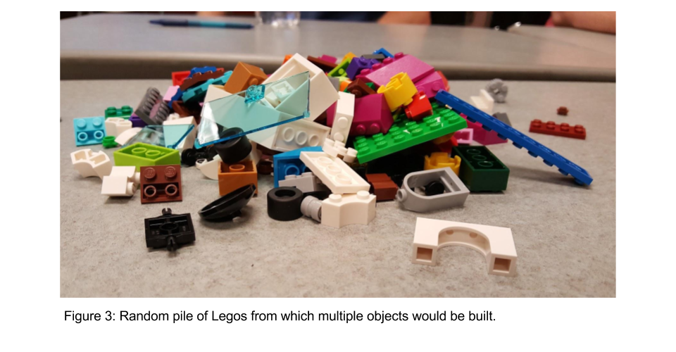
Mr. Smith then shared with the class his experience deploying CBL lessons with his high school physics class. He pointed out that he struggled with some of the implementation (and had to radically rework his first unit on sound-proofing a box), but his students found fresh opportunities for learning through failure and that they were able to surprise him with their innovative thinking and pursuit of learning. He also highlighted for the workshop participants that CBL is meant to be done a few times a year, not as a complete curricular replacement. With his honors physics students, he introduced a rocket design challenge that required students to build rocket vehicles that could reliably fly from a set launch point and land 50 meters away in a target zone (relatively easy), while carrying an unbroken raw egg (relatively difficult). For students who were intimidated by the egg, he permitted them to opt for a starting project grade of 88% instead of 100%, making it clear that any student who wanted to earn an “A” for the project would know that they had to embrace the egg survival requirement.

Both facilitators emphasized the importance of deadlines and accountability. Without tangible urgency, many students will lose focus and stop working toward learning goals. Thus, it is important to design units such that students feel urgency with their deliverables.

